A snapshot of the solar eclipse at 99.99% total coverage in Coles Island New Brunswick.
I did not doctor up the picture below. It was taken at the time closest to total eclipse. We are on the edge of the "total" path and we could look briefly at the moon and sun for a few seconds without eye protection. We saw just a ring around the moon with a bright spot on the edge. We did not see what appeared to be a jet aircraft just above the sun's position as we were all talking and not listening to try to hear anything like the sound of a jet.
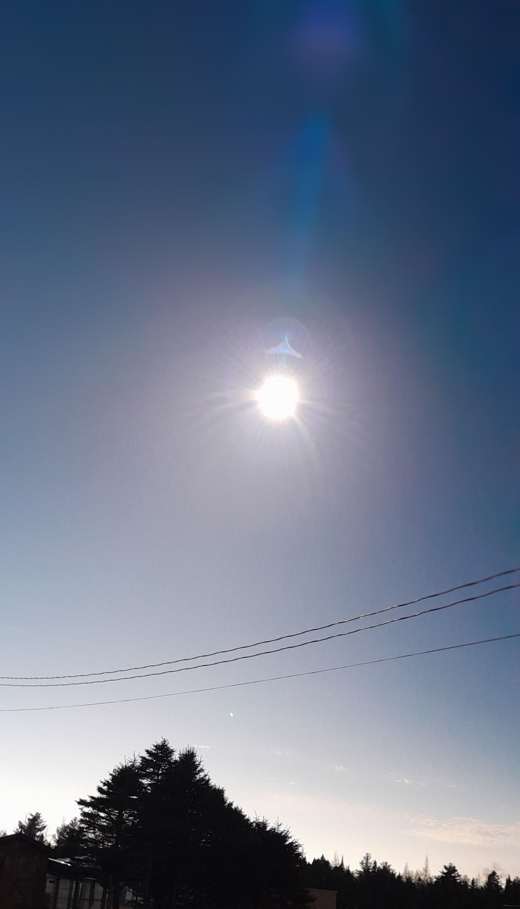
There have been a lot of crazy stories about agents of the deep state taking the opportunity to spray aerosols in the path of the shadow undetected, but we ignored the stories. We were not expecting to see this on the photo. Surely the stories were not true. What could be the explanation?
Most comments support the explanation that it is an aberration created by the camera but looking deeper, it might have actually been a jet following the path
Delta provided 2 flights specifically to follow the path.
https://news.delta.com/popular-demand-delta-adds-second-eclipse-path-totality-flight
Other airlines did the same.
https://www.cntraveler.com/story/solar-eclipse-2024-flights
https://www.wired.com/story/the-most-extreme-way-to-watch-the-eclipse-chase-it-in-a-jet/
This article described what NASA did during the eclipse.
Scientists Pursue the Total Solar Eclipse with NASA Jet Planes
https://science.nasa.gov/solar-system/skywatching/scientists-pursue-the-total-solar-eclipse-with-nasa-jet-planes/
None of these took a path near to our location but a scheduled fight might have gifted its passengers to a few moments of wonder by slightly deviating from its scheduled flight path. Sylvia and I were given that bonus on a flight past Iceland which had an unusual flow of icebergs south of it. We deviated in a long arc so that the plane could tilt and all could see the splendor of the gleaming white forms on a black sea below a cloudless blue sky.
Although NASA sent three of its WB-57 jets into the path of the eclipse, the image that I captured did not resemble one of those as their shape is quite square, designed for slow flight which permits observation. My image was more streamlined, characteristic of a military jet and some passenger jets.
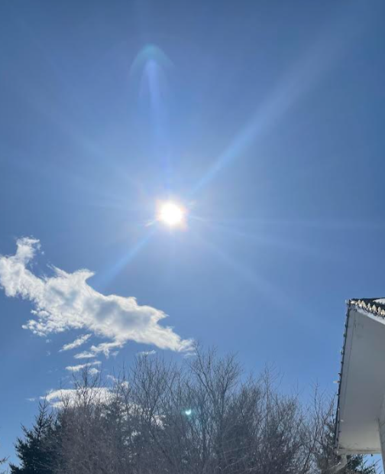
There were other photos taken that showed images or maybe ghost images of planes in the path.
This one was taken by a friend in Maramichi, NB. The airplane shape is fuzzier and is out in front of the eclipse.
Another theory would be that the jet is actually almost within the moon’s shadow, and therefore indistinguishable and the apparent image of the jet is actually its shadow cast upon a moist thermal layer in the atmosphere below. A second similar ghost of an image can be faintly seen in my picture closer to the top. Maybe our local atmosphere was dryer and showed less shadow.
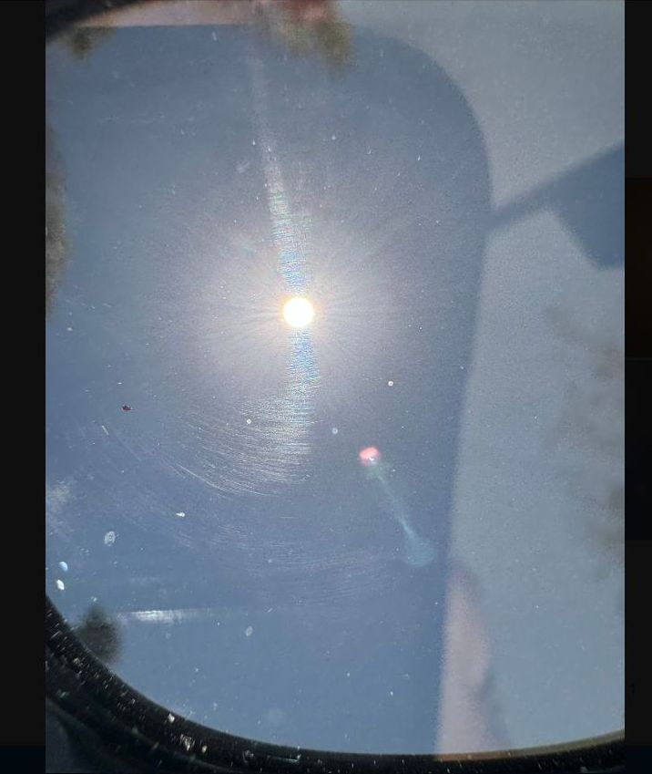
This picture is from a weather channel.
It is surely an aircraft! A red navigation light is blinking at its nose; the wings are swept back away from the centre of the photo and either a shadow or possibly jet exhaust trails behind it. Note that the wings in the other photos sweep toward the centre of the photo and this one sweeps away. I don’t think camera lens manufacturing anomalies would embrace such a variance. And the image of the plane is similar to the one in my picture.
I give it 50-50 that they are aircraft.
All in all, a fun day!
Wayne

